HONG KONG INSTITUTE OF VOCATIONAL EDUCATION
Laboratory 7a: Tkinter

TASK:
1. With reference from lecture notes, integrate several widgets to form a whole application. The UI design and source code template are given below.

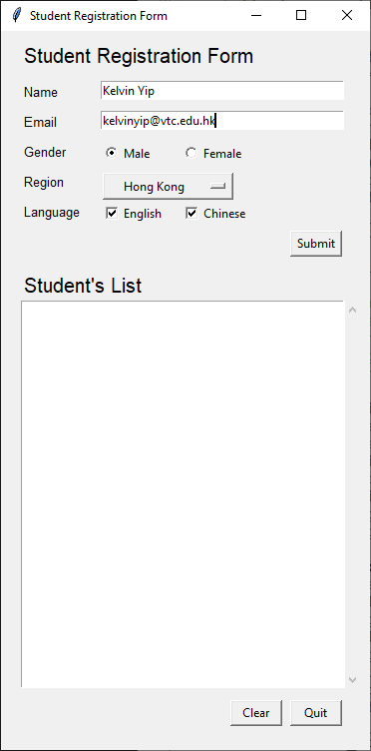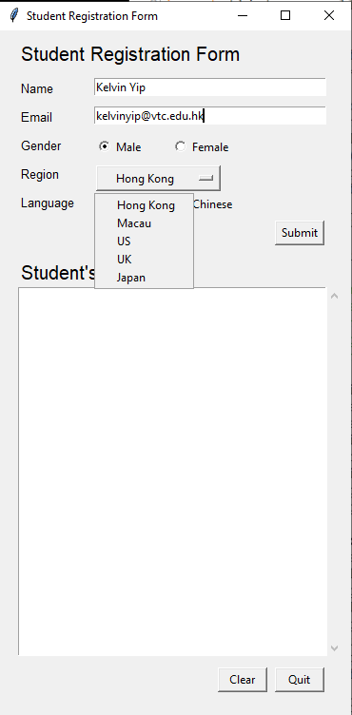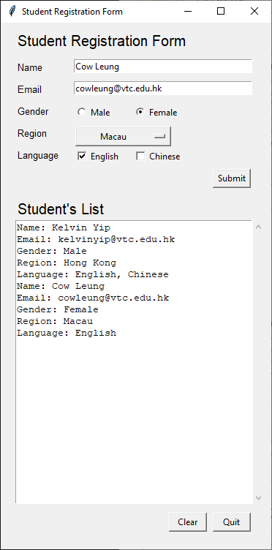

Source code template:

#Import necessary modules here

#Implement Student class with __init__ method
# and __str__ method here
class Student:
pass

#Implement the GUI applicaion class here
class Application(tkinter.Tk):

#All widgets in the Student Registration Form
# would be initialized / cleared
def reset_form(self):
pass #Remove this line and start implementation here

#Actions performed by clicking the Submit button
def submit(self):
#Create student object and put into the student list
#Clear the ScrolledText widget
#Display student objects in list to ScrolledText widget

#call reset_form() function to clear the input form
# after submission
self.reset_form()

#Actions performed by clicking the Clear button
def clear(self):
#Clear the student list
#Clear the ScrolledText widget
Pass #Remove this line and start implementation here

def __init__(self):
#instance variable used to store the student object
# after clicking Submit button
self.list_student = list()
super().__init__()

#Detailed Implementation here

#Better to initialize the form once
# after putting all widgets on Tk
self.reset_form()

if __name__ == "__main__":
app = Application()
app.mainloop()

Answer:

